MODULE - 4
Data Preprocessing using WEKA
ECOMMERCE MANAGEMENT SYSTEM
Aim:
To perform basic data preprocessing operations such as Discretization and Feature Selection using WEKA.
Data Preprocessing using WEKA:
Step 1: Load dataset in Weka
Opening the Road Traffic Dataset in CSV format from explorer options in Weka for performing data preprocessing operations.
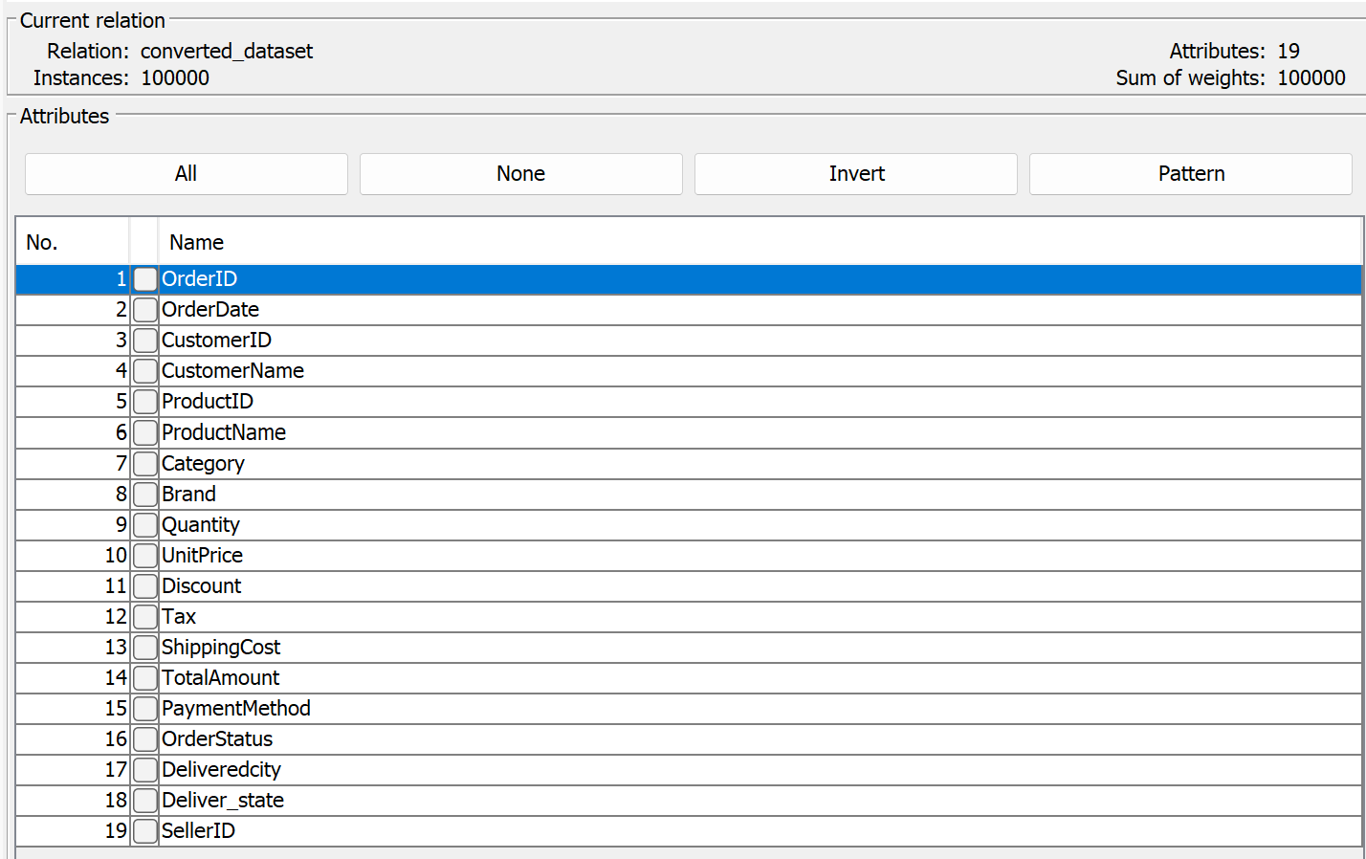
Fig 1.1 Loading Dataset in Weka

Step 2: Explore dataset using visualization charts
Use the "Visualize" option to explore statistical summaries, histograms, scatterplots, etc., to get insights into the distribution of data.
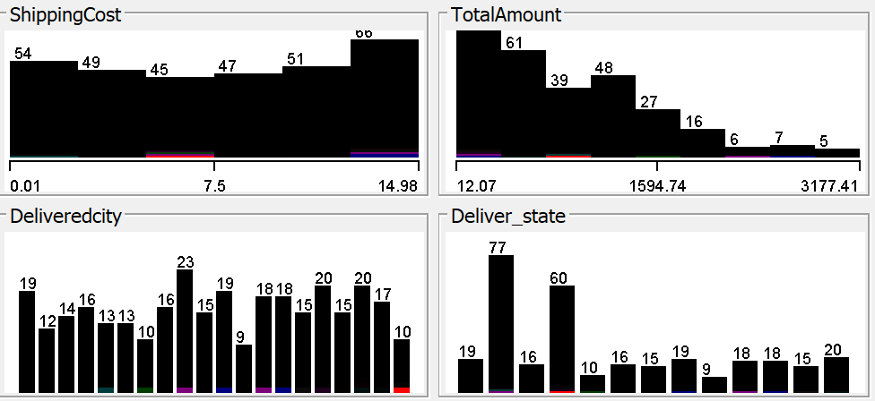
Fig 2.1 Visualization of Dataset
Step 3: Apply Preprocessing Techniques
- Discretization:
If dataset contains continuous attributes that need to be discretized, use the "Discretize" filter to convert them into discrete intervals.
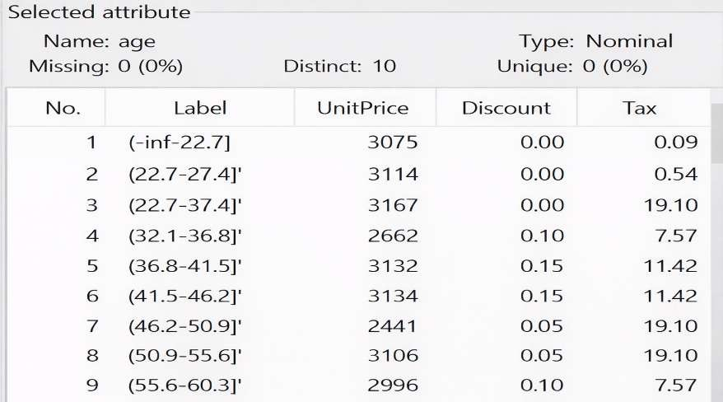
Fig 3.1 After Discretizing age column

- Data - Feature Selection:
It is the process of reducing the number of input variables (features) in a dataset by selecting only the most relevant, useful, or informative ones for building a predictive model.
Dataset before feature selection:
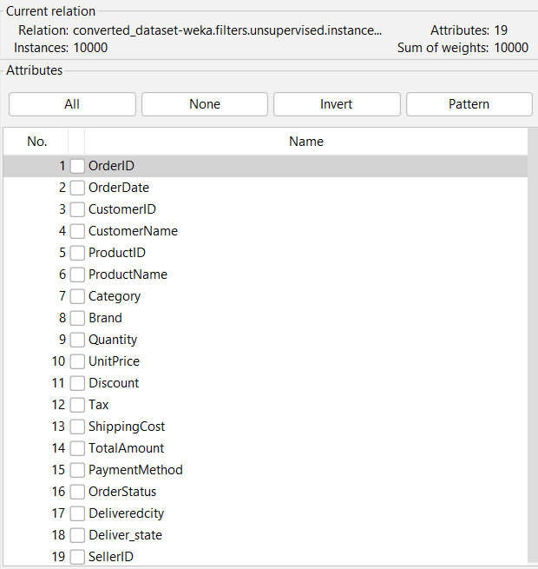
Fig 3.2 Before applying feature selection to the dataset
Configuring feature selection:
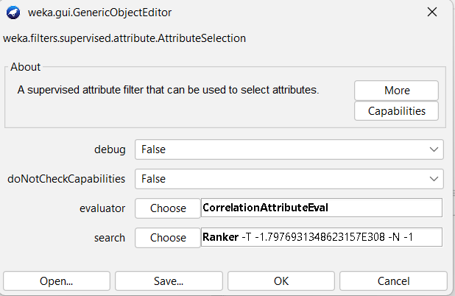
Fig 3.3 Configuring feature selection to the dataset
Step 4: Questions and feature ranking:
Select target column and its dependent columns for the questions, subset them and rank them using ranker in Weka.
- Can customers be classified as High-Risk or Low-Risk based on their return behavior and purchase history?
Target Column: OrderStatus
Independent Columns: OrderDate, Category, TotalAmount, PaymentMethod
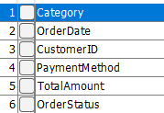
Fig 4.1 View of subset
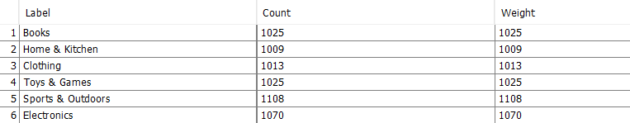
Fig 4.2 Rank of subset
- Can customers be classified as High-Risk or Low-Risk based on their return behavior and purchase history?
Target Column: OrderStatus
Independent Columns: CustomerID, TotalAmount, PaymentMethod, City
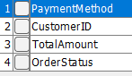
Fig 4.3 View of subset
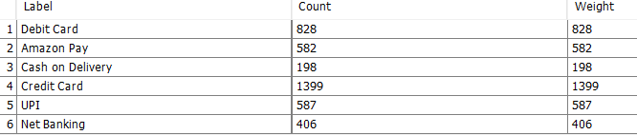
Fig 4.4 Rank of subset
- Can we predict the optimal Discount percentage required to increase Quantity sold without reducing profit?
Target Column: Quantity
Independent Columns: Discount, UnitPrice, Category, Brand
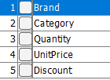
Fig 4.5 View of subset
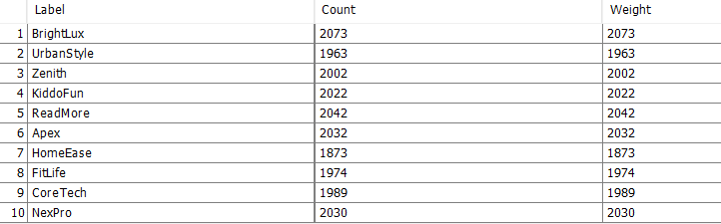
Fig 4.6 Rank of subset
- Can we predict whether a product actually needs a discount (Yes/No) based on demand trends and Category?
Target Column: Discount
Independent Columns: Quantity, Category, UnitPrice, Brand
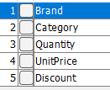
Fig 4.7 View of subset
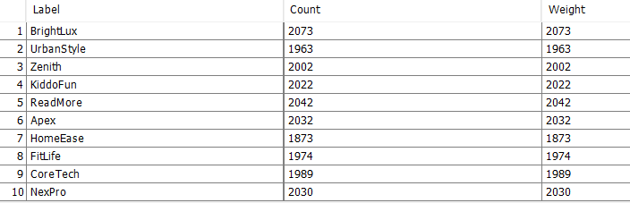
Fig 4.8 Rank of subset
- Does the launch of a new ProductID reduce the Quantity sold of an existing product within the same Category?
Target Column: Quantity
Independent Columns: ProductID, OrderDate, Category
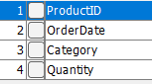
Fig 4.9 View of subset
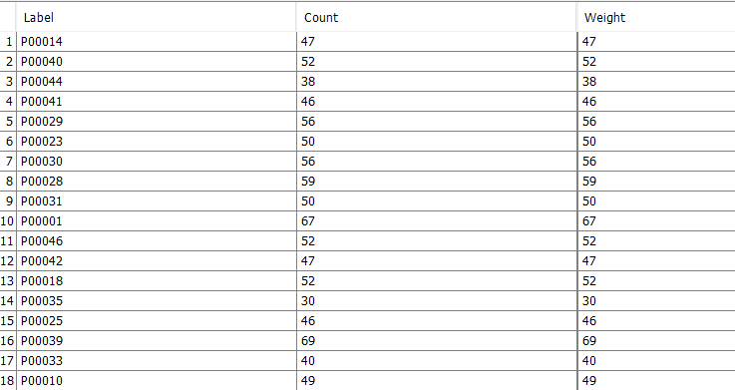
Fig 4.10 Rank of subset

- Can we detect product cannibalization by identifying customer switching behavior between similar products?
Target Column: ProductID
Independent Columns: CustomerID, Category, Brand, UnitPrice
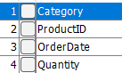
Fig 4.11 View of subset
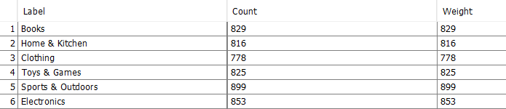
Fig 4.12 Rank of subset
- Can we classify products as Stable, Seasonal, or Unpredictable based on Quantity and OrderDate trends?
Target Column: Quantity
Independent Columns: OrderDate, ProductID, Category

Fig 4.13 View of subset

Fig 4.14 Rank of subset

- Can we predict ShippingCost using City, State, and Quantity to identify high-cost logistics regions?
Target Column: ShippingCost
Independent Columns: City, State, Quantity, TotalAmount
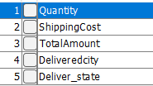
Fig 4.15 View of subset
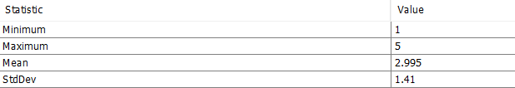
Fig 4.16 Rank of subset
- Which products should be bundled together to increase TotalAmount per shipment and reduce logistics loss?
Target Column: OrderID
Independent Columns: ProductID, Category, TotalAmount, CustomerID
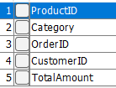
Fig 4.17 View of subset
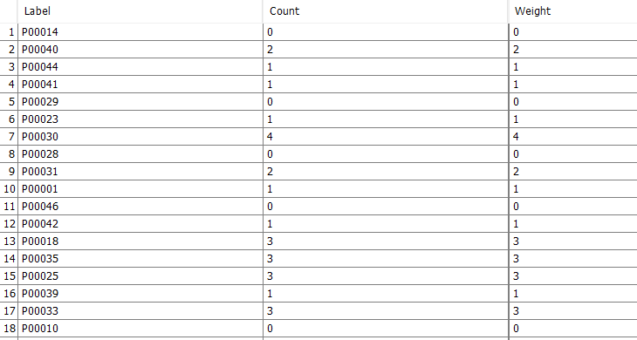
Fig 4.18 Rank of subset
- Can we predict future price drops for a product using historical UnitPrice and Discount cycles?
Target Column: UnitPrice
Independent Columns: OrderDate, Discount, Brand, Category
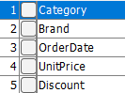
Fig 4.19 View of subset
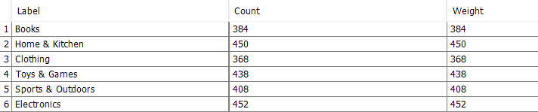
Fig 4.20 Rank of subset
- Can we identify products that belong to multiple categories using ProductName and Category features?
Target Column: Category
Independent Columns: ProductName, ProductID, Brand, UnitPrice
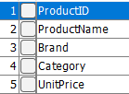
Fig 4.21 View of subset
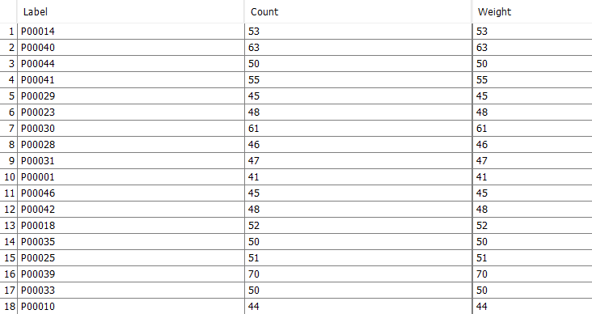
Fig 4.22 Rank of subset
- Can we recommend a legally valid lower-tax category for dual-category products to improve margins?
Target Column: Tax
Independent Columns: Category, ProductName, State, UnitPrice
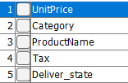
Fig 4.23 View of subset
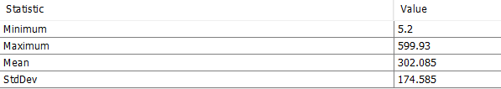
Fig 4.24 Rank of subset
- Can customers be clustered into VIP, Budget, and Occasional Buyers using TotalAmount and order frequency?
Target Column: TotalAmount
Independent Columns: CustomerID, OrderDate, Quantity
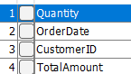
Fig 4.25 View of subset
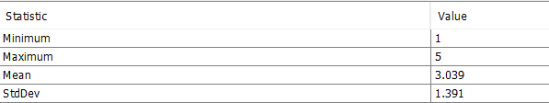
Fig 4.26 Rank of subset
- Can Cities/States be clustered into High-Profit and Low-Profit regions based on TotalAmount and ShippingCost?
Target Column: TotalAmount
Independent Columns: City, State, ShippingCost, Tax
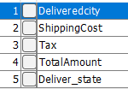
Fig 4.27 View of subset
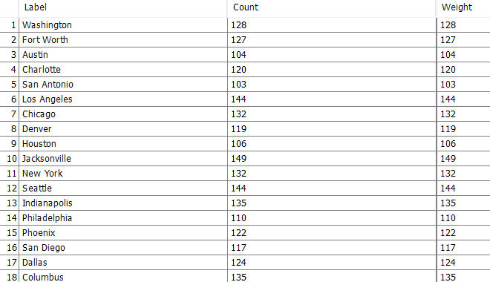
Fig 4.28 Rank of subset
- Can we predict future revenue for a SellerID based on historical OrderDate and TotalAmount trends?
Target Column: TotalAmount
Independent Columns: SellerID, OrderDate, Category
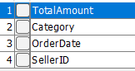
Fig 4.29 View of subset
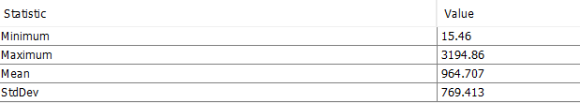
Fig 4.30 Rank of subset
- Can we predict the likelihood of an order being Cancelled before delivery based on PaymentMethod, OrderDate (day of week), and ShippingCost?
Target Column: OrderStatus
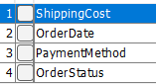
Independent Columns: PaymentMethod, OrderDate, ShippingCost

Fig 4.31 View of subset
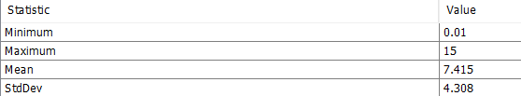
Fig 4.32 Rank of subset
- Can we build a fair risk score that detects fraud without penalizing specific PaymentMethods (UPI/COD vs Card)?
Target Column: OrderStatus
Independent Columns: PaymentMethod, TotalAmount, City, State
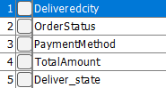
Fig 4.33 View of subset
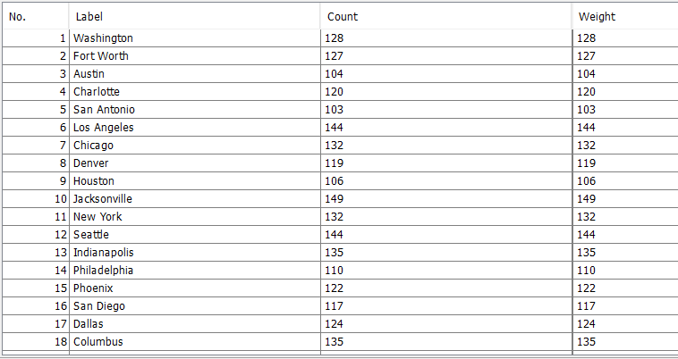
Fig 4.34 Rank of subset
- What is the profit impact of discounts on different Categories when ShippingCost and Tax are considered?
Target Column: TotalAmount
Independent Columns: Discount, ShippingCost, Tax, Category
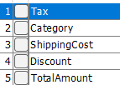
Fig 4.35 View of subset
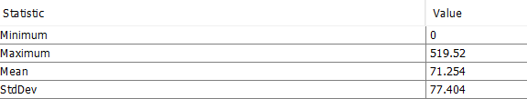
Fig 4.36 Rank of subset
- Can we predict the minimum discount required to move slow-selling products without affecting high-demand items?
Target Column: Discount
Independent Columns: Quantity, Category, UnitPrice
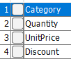
Fig 4.37 View of subset
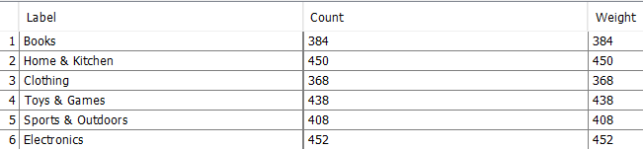
Fig 4.38 Rank of subset
- Which Products or Categories generate logistics losses (ShippingCost ≈ UnitPrice), and how can they be grouped for bundling?
Target Column: ShippingCost
Independent Columns: UnitPrice, Quantity, Category, ProductID
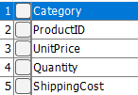
Fig 4.39 View of subset
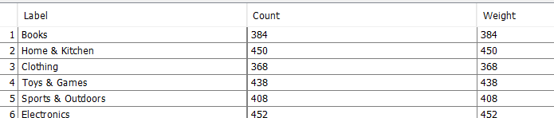
Fig 4.40 Rank of subset

Step 5:
Save preprocessed Data after cleaning /normalization/visualization,save the preprocessed dataset by clicking on the “Save” button.

Result:
Thus, data preprocessing operations such as data discretization and feature selection for subsets of the questions were performed using WEKA.

